Suricat Website Redesign (Landing Page)

TOP BANNER:
Navigation BAR:
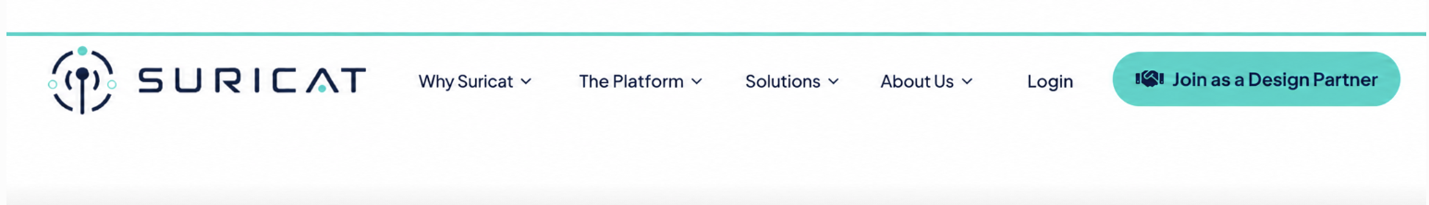

CTAs:
Only three CTAs
1) Join as a Design Partner
2) Request a Free Pilot
3) Got Questions?

Hero Section Message:

The Sentinel for Compliance Intelligence
Suricat works alongside existing QMS and other quality systems to surface potential quality issues, compliance gaps, and misalignments across documents and records, link each one to its source evidence, and help QA/RA teams address them before an auditor finds them.

HERO VISUAL:

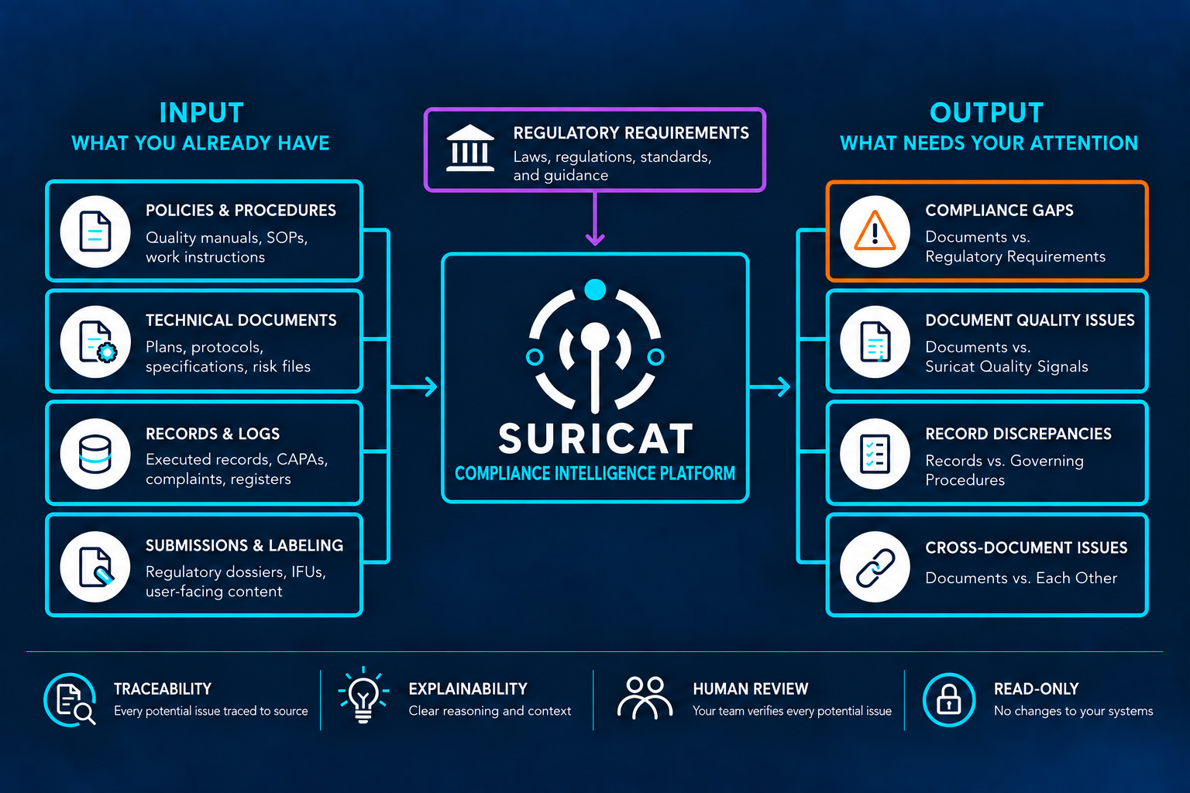

1) THE COST OF MISALIGNMENT

Misalignment Can Stay Hidden Until It Matters.

Quality and compliance issues can go unnoticed when related information across requirements, documents, and records no longer lines up.

By the time an audit, inspection, or recall exposes them, the financial and operational impact can be significant.

The information may exist. The relationships can still be missed.
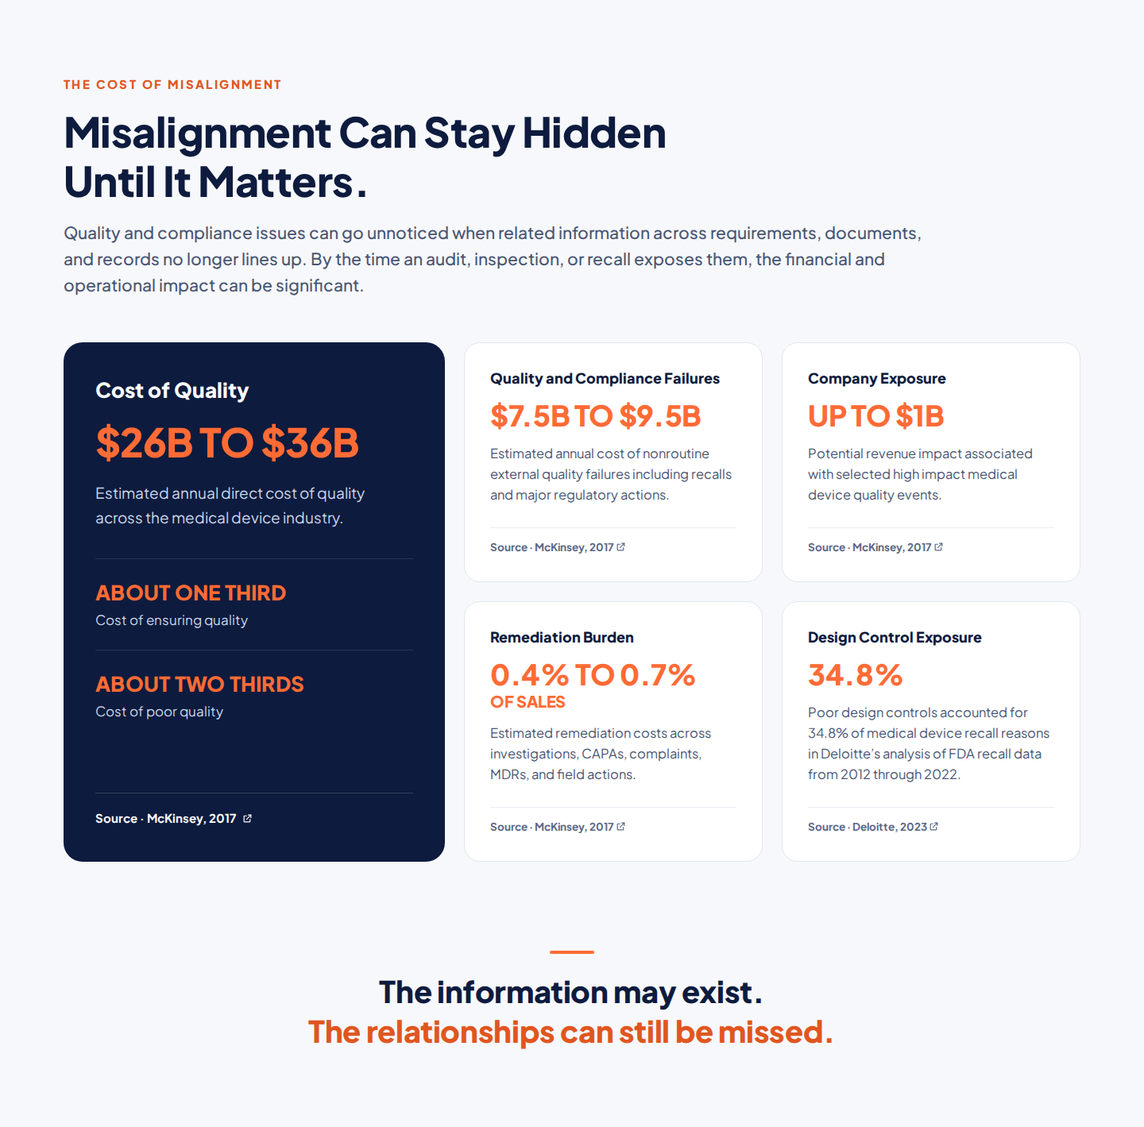
Cost of Quality · $26B to $36B | McKinsey · Capturing the value of good quality in medical devices mckinsey
Quality and Compliance Failures · $7.5B to $9.5B | McKinsey · External quality failure costs mckinsey
Company Exposure · Up to $1B | McKinsey · Revenue impact of major quality events mckinsey
Remediation Burden · 0.4% to 0.7% of sales | McKinsey · Remediation costs mckinsey
Design Control Exposure · 34.8% | Deloitte · MedTech Quality Costs deloitte
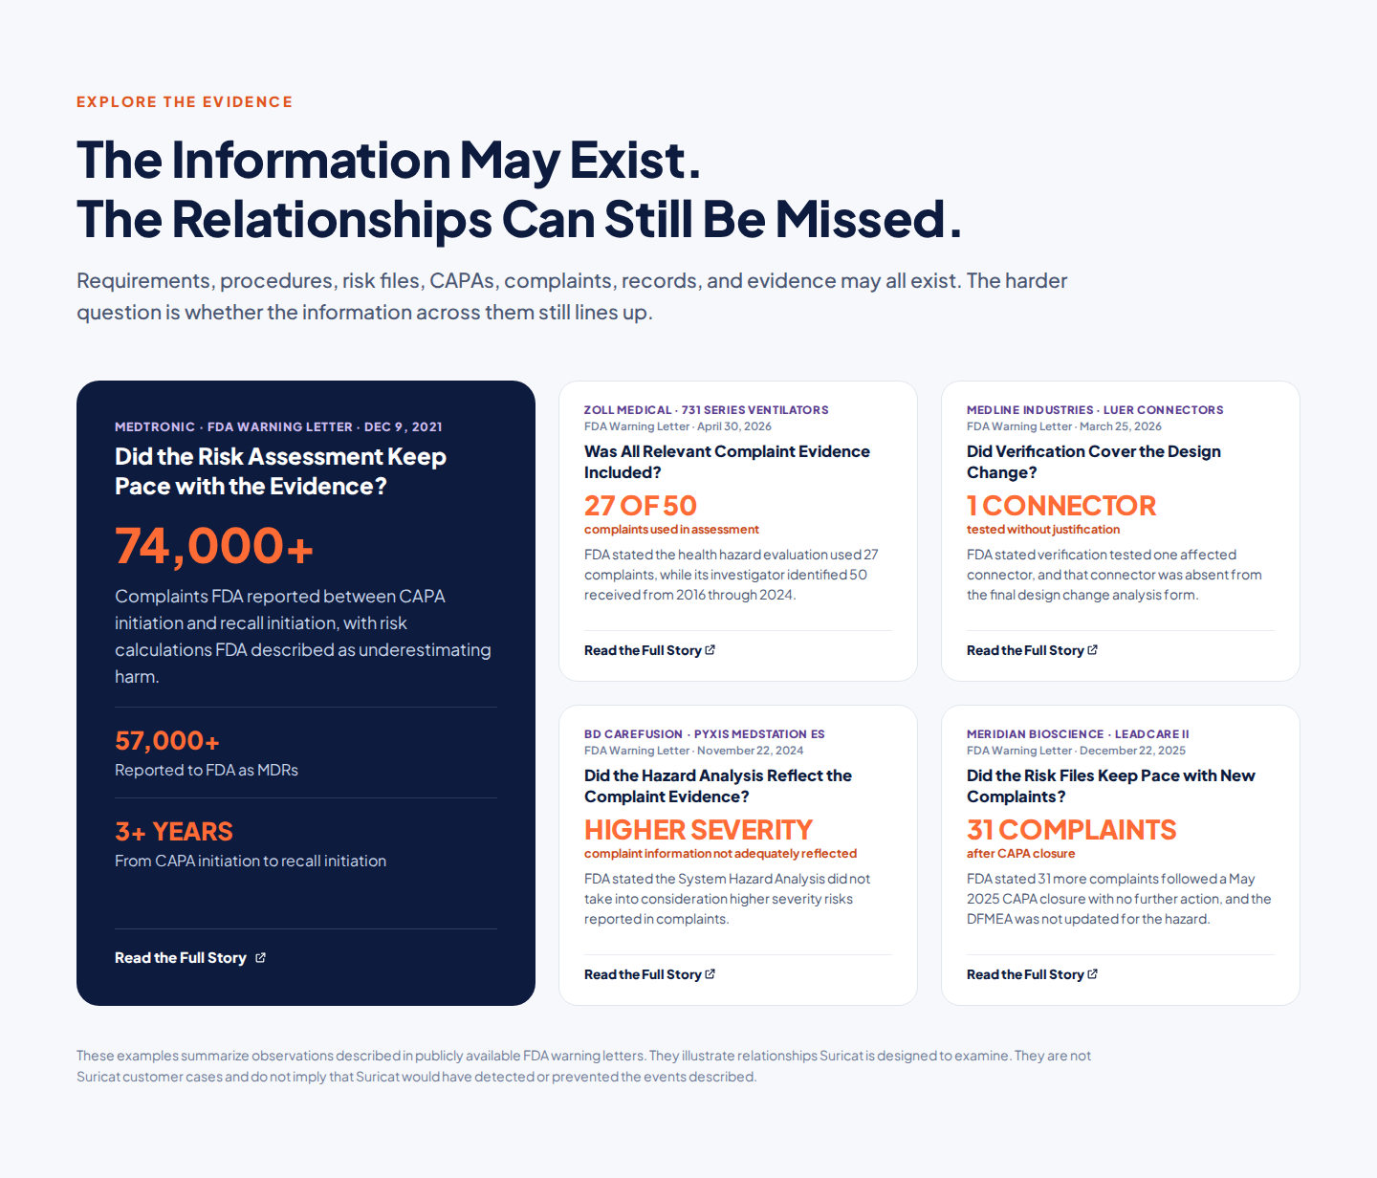

Story | Direct link to the FDA webpage | Relevant section
Medtronic · 74,000+ complaints | FDA warning letter · December 9, 2021 fda | 1(a)(iii) for the complaint and MDR counts
ZOLL Medical · 27 of 50 complaints | FDA warning letter · April 30, 2026 fda | 3(A) for the 731 ventilator assessment
Medline Industries · One connector tested | FDA warning letter · March 25, 2026 fda | 3 for design verification and connector coverage
BD CareFusion · Higher severity complaint information | FDA warning letter · November 22, 2024 fda | 3 for the MedStation ES System Hazard Analysis
Meridian Bioscience · 31 complaints after CAPA closure | FDA warning letter · December 22, 2025 fda | 1(A) for the 31 complaints; 3(B) for the DFMEA update issue

2) THE ALIGNMENT GAP
Quality Systems Are in Place. Alignment Is the Hard Part.
Requirements change. Documents evolve. Evidence accumulates.
Procedures, risk files, CAPAs, design control documentation, and training records depend on one another, even across different systems.
When one changes, what else is affected?
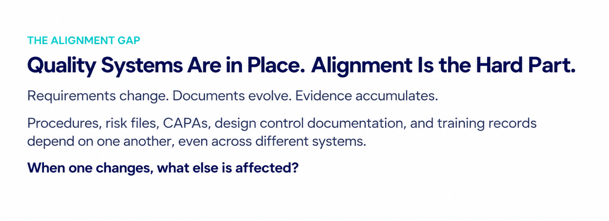

The Alignment Gap Dynamic Visual:
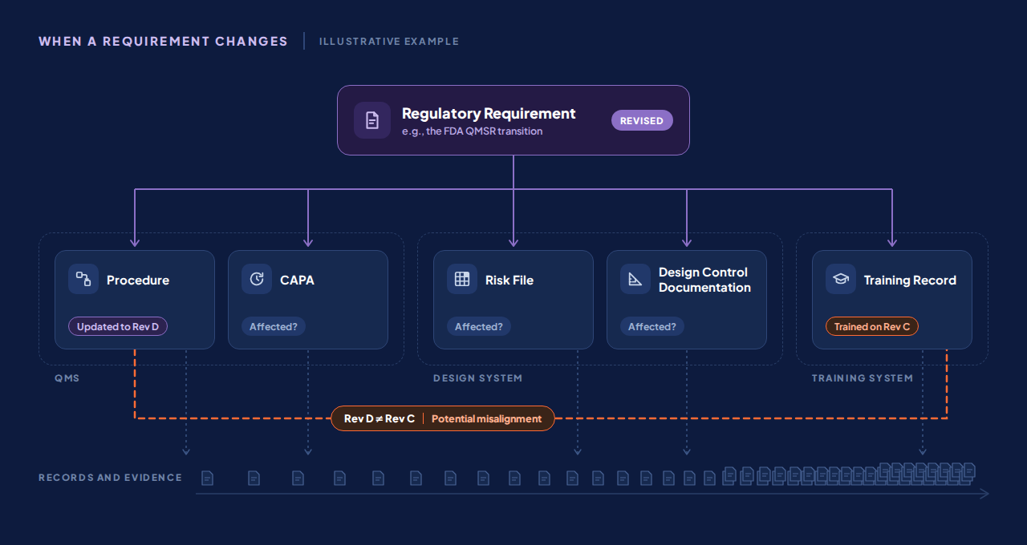

3) BEYOND EXISTING SYSTEMS

Existing Systems Manage the Information. Alignment Is Still the Challenge.

QMS and other quality systems manage documents, records, workflows, and approvals.

Compliance also depends on how that information relates to applicable requirements and to other documents and records.

Suricat works alongside those systems to surface where related information may no longer line up.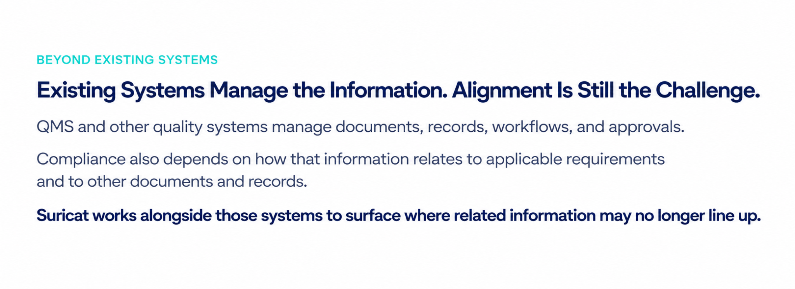BEYOND EXISTING SYSTEMS Dynamic Visual

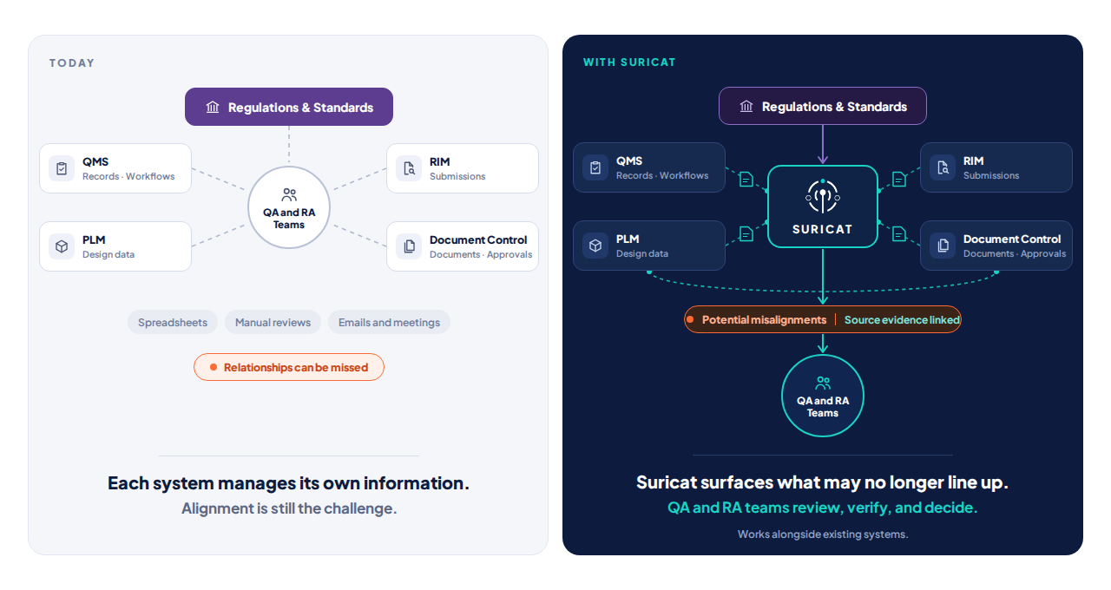
4) BUILT FOR REGULATED ENVIRONMENTS
Intelligence Without Giving Up Control.
Suricat fits into existing quality and regulatory environments while keeping QA and RA professionals in control.
Human Accountability
Suricat identifies potential compliance issues and links each one to its source evidence. QA and RA professionals review each potential issue, verify the evidence, and decide what to do. Responsibility for every decision remains with them.
No Rip and Replace
Existing QMS and document control systems stay in place. Suricat works alongside those systems and established processes.
Read Only by Design
Suricat evaluates compliance information without modifying controlled documents or source records. Existing approval processes and document controls remain intact.
Data Ownership
Documents, records, and compliance information remain the customer's property. Customer data is not shared with other customers or used to train AI models without explicit written consent.
Dedicated Instance
Each customer receives a dedicated Suricat instance, keeping compliance information isolated from other organizations.
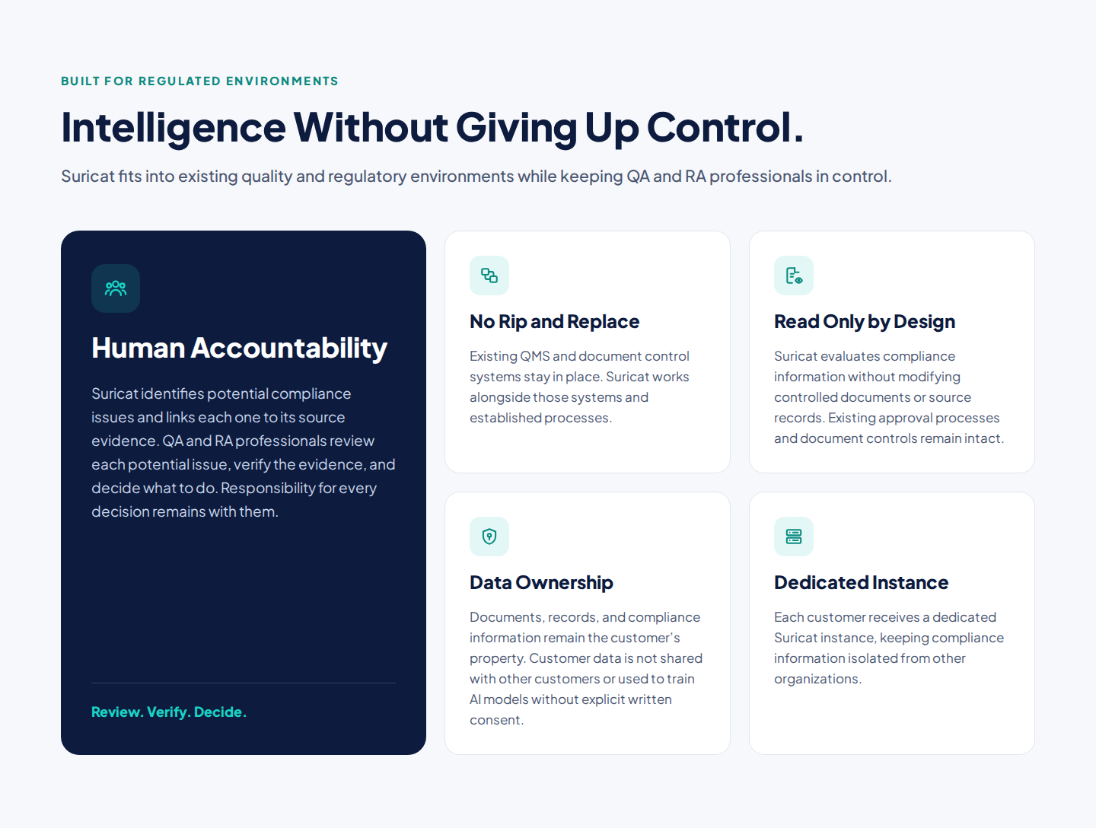

WHY SURICAT (CLOSING PUNCHLINE)

Know What Needs Attention. Before It Becomes a Finding.
Gaps and misalignments rarely announce themselves. Suricat surfaces potential issues with the source evidence behind them, so QA and RA teams can review, verify, and decide.
Less time searching. More confidence in every review.

Ready to See Suricat in Action?
[Join as a Design Partner] [Request a Free Pilot ]
Got Questions?
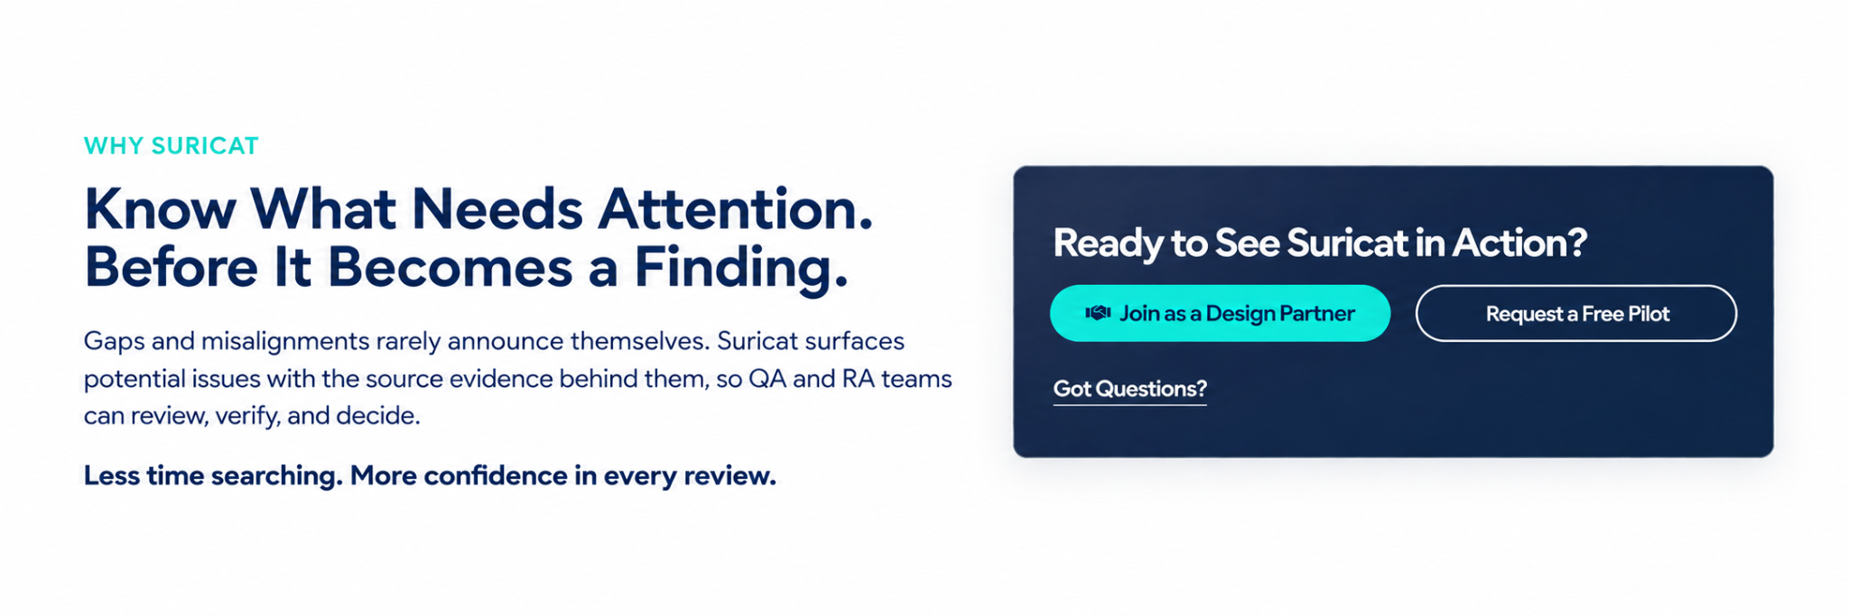
DESIGN PARTNER BAND
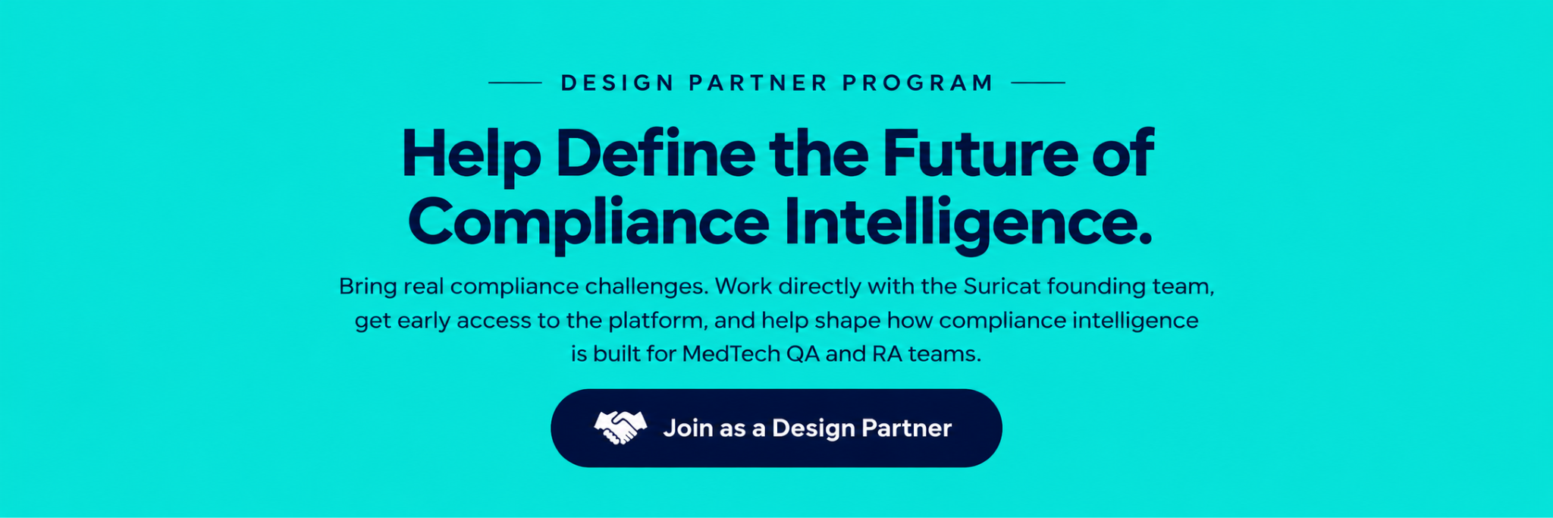

FOOTER

